Indie Fusion

Team Members
Twinkle Akhilesh Mishra
Sruthi Kamishetti
Naina Jagiasi
Team Number: 1

Course Code: INFO8106 (102)

Mentors Name: Regan Benner
Clients Name: DreamWave Productions

Due Date: November 1, 2024

SrNo. | Table of Contents | Page
1. | Use Case Diagrams | 3-5
2. | Use Case Descriptions | 6-12
3. | Wireframes | 13-14
4. | Link to Video | 14
Index

Use Case Diagrams

Artist Use case Diagram

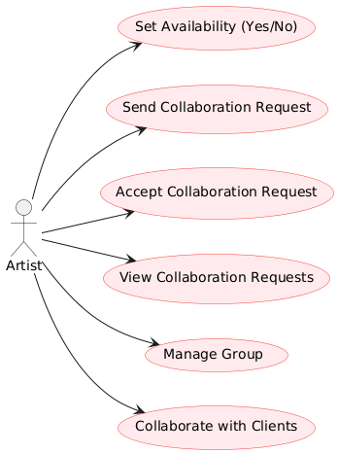
Client Use case Diagram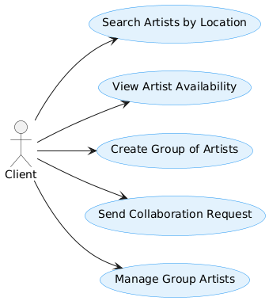

System Use Case Diagram
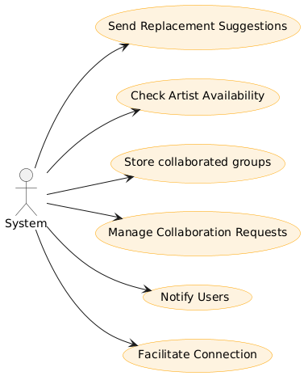

Use Case Descriptions
Note: Users can be considered as Artist as well as Client.
Use Case 1: Search Artists by Location
Attribute | Description
Use Case Name | Search Artists by Location
Use Case No. | UCD01
Scenario | The user searches for artists based on location.
Triggering Event | User initiates a search.
Brief Description | Users can filter artists by geographical location.
Actors | User, System
Stakeholders | Users, Artists
Preconditions | User is logged in and updated location details in profile.
Postconditions | The system returns a list of artists based on search criteria.
Flow of Activities | 1. User enters search criteria.  2. System retrieves matching artists.  3. System displays the list of artists.  4. User selects an artist for more details.
Exception Conditions | - If no artists are found, a message is displayed.  - If artist does not have location details, it would not be displayed.

Use Case 2: Create Group of Artists
Attribute | Description
Use Case Name | Create Group of Artists
Use Case No. | UCD02
Triggering Event | A user’s collaboration request is accepted by another artist to form a group.
Brief Description | Users can create a group by selecting multiple artists and sending collaboration requests. The system designates the initiator as the group admin.
Actors
  Users, System
Stakeholders | Users, Artist
Preconditions | The user is logged into the system.  The user has selected artists to invite to the group.
Postconditions | A new group is created, including the selected artists.  The user who initiated the request is assigned as the group admin.
Flow of Activities | 1. User selects artists: The user selects other artists from the list to invite into the group collaboration.  2. System creates the group: The system creates the group based on the provided details and assigns the user as the group admin.  3. System notifies artists: The system sends a notification to the selected artists, informing them of the invitation.  4. Admin status assigned: The initiating user becomes the admin of the newly created group, responsible for managing collaboration.
Exception Conditions | If group creation fails: The system displays an error message.  If an artist declines the invitation: The artist is not added to the group, and the system notifies the admin..
Triggering Event | A user’s collaboration request is accepted by another artist to form a group.

Use Case 3: Send Individual Collaboration Request
Attribute | Description
Use Case Name | Send Individual Collaboration Request
Use Case No. | UCD03
Scenario | The User sends an individual collab request to another artist to collaborate
Triggering Event | User selects another artist to collaborate.
Brief Description | User can request collaboration.
Actors | User, System
Stakeholders | Artists
Preconditions | User is logged in.
Postconditions | The collaboration request is sent to the target artist.
Flow of Activities | - User sends an individual collaboration request.  - System notifies the recipient.  - System logs the request.  - User can send individual collab requests to multiple artists.
Exception Conditions | If the target artist does not exist, an error is shown.

Use Case 4: Accept Collaboration Request
Attribute | Description
Use Case Name | Accept Collaboration Request
Use Case No. | UCD04
Scenario | The artist accepts a collaboration request from user.
Triggering Event | Artist receives a collaboration request.
Brief Description | The receiving artist can accept or reject collaboration requests.
Actors | Artist, System
Stakeholders | Artists
Preconditions | Artist is logged in and has received a request.
Postconditions | The individual collaboration request is accepted, and both artists are notified.
Flow of Activities | 1. Artist views incoming requests.  2. Artist selects a request to accept or reject.  3. System updates the request status.  4. System notifies both artist and user of the status.
Exception Conditions | If the acceptance fails, an error message is displayed.

Use Case 5: Set Availability
Attribute | Description
Use Case Name | Set Availability
Use Case No. | UCD05
Scenario | The artist sets their availability status for collaboration.
Triggering Event | Artist decides to update their status.
Brief Description | Artists can indicate whether they are available (Yes/No) for any collaboration.
Actors | Artist, System
Stakeholders | Artists
Preconditions | Artist is logged in.
Postconditions | The availability status is updated in the system.
Flow of Activities | 1. Artist navigates to profile settings.  2. Artist selects Yes/No for availability.  3. System updates the status.  4. System confirms the update to the artist.  5. The updated status is shown to users.
Exception Conditions | If the update fails, an error message is shown.

Use Case 6: Filter Artists by Availability
Attribute | Description
Use Case Name | Filter Artists by Availability
Use Case No. | UCD06
Scenario | The user filters artists based on their availability status.
Triggering Event | User initiates a filter.
Brief Description | Users can filter the list of artists to show only those who are available for collaboration.
Actors | User, System
Stakeholders | Users, Artists
Preconditions | User is logged in.
Postconditions | The system displays a filtered list of available artists.
Flow of Activities | 1. User selects filter options.  2. System retrieves artists matching the criteria.  3. System displays the filtered list.
Exception Conditions | If no artists match the criteria, a message is displayed.

Use Case 7: Notify Users of Collaboration Status
Attribute | Description
Use Case Name | Notify Users of Collaboration Status
Use Case No. | UCD07
Scenario | The system sends notifications to users regarding the status of collaboration requests.
Triggering Event | A collaboration request is accepted or rejected.
Brief Description | The system automatically notifies users about changes in their collaboration requests.
Actors | System
Stakeholders | Users, Artists
Preconditions | A collaboration request has been sent or updated.
Postconditions | Users receive notifications about request status.
Flow of Activities | 1. System updates a status change.  2. System retrieves user information.  3. System sends notification to relevant users.  4. System logs the notification activity.
Exception Conditions | If notification fails, an error message is displayed.

Wireframes

Working Code Demonstration
[Insert link to recorded video]

